Forces, Mass and Weight — Practice Set
Name: Class: Date:
54 questions 70 marks

Question 1 1 mark
Sam claims that tension in a rope and gravity are both non-contact forces because both can pull without pushing. What is wrong with Sam’s claim? (1)
a. Tension needs contact through the rope, while gravity pulls without contact.
b. Gravity needs air contact to pull, while tension acts without contact.
c. Both need contact, because gravity needs the ground to act.
d. Both are non-contact, because a rope can pull from a distance.

Question 2 1 mark
Priya sorts forces into two groups. Contact: gravitational force, frictional force. Non-contact: magnetic force, electrostatic force. Which correction fixes her table? (1)
a. Move gravitational force to non-contact; the other three are already in the right groups.
b. Move frictional force to non-contact; rubbing does not need touching.
c. Move magnetic force to contact; magnets must touch to attract.
d. Move electrostatic force to contact; charged objects must touch to repel.

Question 3 1 mark
A diver of mass $60 \text{kg}$ travels to the Moon where gravity is about one-sixth of Earth’s. Her friend predicts her mass will become $10 \text{kg}$ and her weight will stay unchanged. Which statement corrects the friend? (1)
a. The mass stays $60 \text{kg}$ and the weight becomes about one-sixth of the weight on Earth.
b. The mass becomes about $10 \text{kg}$ and the weight stays the same as on Earth.
c. The mass and the weight both stay the same as on Earth.
d. The mass and the weight both become about one-sixth of their values on Earth.

Question 4 1 mark
Caught in an open field in a lightning storm, a guide advises: “Stand under that lone tree to stay dry and stand tall to see the path.” What is the unsafe error in this advice and what should be done instead? (1)
a. The lone tree and staying tall are dangerous; move away from tall objects and crouch low to make yourself small in the open.
b. Running home fast across the open field is safest because lightning cannot catch a runner.
c. Standing next to a tall metal pole is safest because the pole will block the rain.
d. Lying flat on the wet ground is safest because it makes you the lowest object.

Question 5 1 mark
Look at the boy holding the bag still. A student says: “The bag is not moving, so only the boy’s upward pull acts; gravity stops acting when you hold something.” Which statement corrects him? (1)
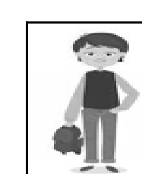
Boy holding a bag
a. Gravity still pulls down on the bag while the hand pushes up; the two balance to keep it still.
b. Only Earth’s gravity pulls on the bag; the hand does nothing once the bag is still.
c. Only the boy’s muscular force acts; gravity stops acting when motion stops.
d. No forces act at all because the bag is at rest.

Question 6 1 mark
The figure shows three forces acting on the object. A learner adds $50+30+60=140 \text{N}$ to the right, ignoring direction. What is the correct magnitude and direction of the net force? (1)
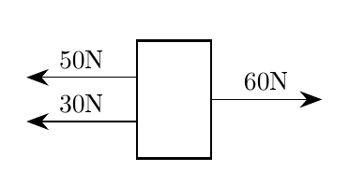
Three forces acting on an object
a. $20 \text{N}$ to the left
b. $20 \text{N}$ to the right
c. $140 \text{N}$ to the right
d. $80 \text{N}$ to the left

Question 7 1 mark
A plastic comb rubbed with a dry wool cloth becomes negatively charged. A learner claims: Protons moved from the cloth onto the comb, making it negative. Which statement identifies the error and gives the correct transfer? (1)
a. Protons moved from the cloth to the comb, as the learner said, making it negative.
b. Electrons moved from the cloth to the comb; protons stay in the nuclei and do not transfer by rubbing.
c. Both protons and electrons moved together from the cloth to the comb.
d. The comb already had excess negative charge and rubbing only revealed it.

Question 8 2 marks
(a) A lemon with a copper strip and a zinc strip inserted can light a small LED. A learner writes: The copper and zinc are the electrolytes and the lemon juice makes electricity on its own. Which correction best explains why the lemon works as a cell? (1)
a. The acidic juice acts as the electrolyte allowing ion movement; the two different metals serve as the electrodes.
b. The copper and zinc strips act as the electrolytes that dissolve to make the current.
c. A natural salt bridge inside the lemon carries electrons through the juice to complete the circuit.
d. The acidic juice alone produces electricity without needing two different metals.

(b) Using the same lemon cell, the learner replaces the zinc strip with a second copper strip and the LED goes out. The learner says the juice ran out. What is the correct diagnosis of this new arrangement? (1)
a. The juice ran out of electricity and a fresh lemon is the only way to restore it.
b. Copper cannot conduct charge in a fruit cell, so the circuit is now broken.
c. The juice is still the electrolyte, but two identical copper electrodes give no potential difference so no current flows.
d. The lemon now needs an extra salt bridge to carry electrons between the two copper strips.

Question 9 2 marks
(a) In a zinc-copper electrochemical cell linked by a wire and a salt bridge, a learner draws arrows showing electrons leaving the cathode and travelling through the salt bridge to the anode. Which statement corrects the error? (1)
a. Electrons flow through the external wire from the anode where oxidation occurs to the cathode where reduction occurs.
b. Electrons flow through the external wire from the cathode to the anode.
c. Electrons flow from the anode to the cathode through the salt bridge.
d. Electrons are carried by the salt bridge to the cathode while ions remain stationary.

(b) For the same cell the learner now shows electrons correctly in the wire but claims no other movement is needed to keep the cell working. Which statement gives the complete correct movement? (1)
a. Electrons go from cathode to anode in the wire and no ion movement is needed.
b. Electrons go from anode to cathode through the salt bridge while ions stay in the wire.
c. Electrons go anode to cathode in the external wire, while ions move in the solutions and salt bridge to balance charge.
d. Both electrons and ions travel together through the external wire from anode to cathode.

Question 10 1 mark
A learner’s notes say: Resistance is the flow of charges around a circuit. Which definition corrects this confusion between resistance and other circuit ideas? (1)
a. A flow of electric charges around a circuit.
b. An electrical component designed to have a high resistance.
c. A source that transfers electrical energy to charges.
d. An opposition offered by a conductor to the movement of charges.

Question 11 2 marks
(a) A learner predicts: shorter wire has higher resistance because charges get squeezed. Which relationship corrects this error? (1)
a. The shorter the conductor, the higher the resistance, as the learner said, because charges get squeezed.
b. The longer the conductor, the higher the resistance, as moving charges suffer collisions over a greater length.
c. The length of the conductor has no effect on resistance; only the current matters.
d. The longer the conductor, the lower the resistance because there is more space for charges.

(b) Two copper wires of the same thickness and temperature are tested: Wire P is 2 m long and Wire Q is 1 m long. The learner says P will have half the resistance because it is longer. Which comparison is correct? (1)
a. The resistance of P is half that of Q because a longer wire lets charge through more easily.
b. The resistance of P is twice that of Q.
c. The resistances are equal; length does not affect resistance.
d. The resistance of P is four times that of Q.

Question 12 2 marks
(a) A circuit has a $4 Ω$ resistor and a $6 Ω$ resistor connected in series. A learner applies the parallel formula $(4×6)/(4+6)=2.4 Ω$. What is the correct total resistance? (1)
a. $10 Ω$
b. $2.4 Ω$
c. $5 Ω$
d. $24 Ω$

(b) The same $4 Ω$ and $6 Ω$ resistors are now reconnected in parallel. The learner simply adds them to get $10 Ω$. What is the correct total resistance for this new arrangement? (1)
a. $10 Ω$
b. $5 Ω$
c. $24 Ω$
d. $2.4 Ω$

Question 13 2 marks
(a) A bulb is connected across one cell with a voltmeter across the bulb. A second identical cell is then added in series aiding (+ to 1). A learner predicts the voltmeter reading will stay the same because the brighter bulb will use up the extra voltage. Which statement corrects the error? (1)
a. Both the voltmeter reading and the brightness of the bulb increase, because the extra cell raises the voltage across the bulb.
b. The voltmeter reading stays the same and only the brightness increases, because the bulb uses up the extra voltage.
c. The voltmeter reading increases but the brightness stays the same, because a voltmeter takes all the extra current.
d. Both the voltmeter reading and the brightness decrease, because more cells use up more energy.

(b) The same bulb and voltmeter are now connected across two identical cells joined + to + so that they push in opposite directions. A learner predicts the brightness will double because there are more cells. Which statement corrects the error? (1)
a. Both the voltmeter reading and the brightness increase to about double.
b. Both the voltmeter reading and the brightness fall to near zero, because the cells oppose each other.
c. The voltmeter reading reverses but the brightness still increases, because any extra cell adds brightness.
d. The voltmeter reading and the brightness stay the same, because two cells always give the same voltage as one.

Question 14 2 marks
(a) Lamps P and Q are connected in parallel across a cell. A switch is placed in series with Q only and is then closed. A learner claims there is still only one pathway for charge. Which statement corrects the error and best describes the circuit? (1)
a. Charge can flow through lamp P or through lamp Q along separate branches.
b. Charge flows in one single loop through the cell, then P, then Q in turn.
c. If lamp P is removed, lamp Q will stop glowing because the circuit is broken.
d. The voltage across Q is higher than across P because Q is nearer the switch.

(b) Three identical lamps R, S and T are connected in parallel to a battery. Lamp S is unscrewed while the battery stays connected. A learner predicts R and T will go out because the circuit is broken. Which statement corrects the error? (1)
a. R and T go out, because a parallel circuit needs every branch to be complete.
b. R and T stay lit but get dimmer, because the voltage is now shared by two lamps.
c. R and T stay lit with the same brightness; each branch still gets the full battery voltage.
d. R gets a higher voltage than T because R is closer to the positive terminal.

Question 15 2 marks
(a) Bulbs P ($10 Ω$), Q ($20 Ω$) and R ($30 Ω$) are connected in series in that order from the positive terminal. A learner claims P will be brightest because current is used up as it goes round. Which statement identifies the error and is correct? (1)
a. All three bulbs have the same brightness because the current is the same.
b. The 10 $Ω$ bulb is brightest because it gets the current first.
c. The 20 $Ω$ bulb is brightest because it is in the middle.
d. The 30 $Ω$ bulb is brightest because with the same current $P=I^{2}R$ is largest for the largest $R$.

(b) Bulbs J ($12 Ω$) between X and Y, K ($36 Ω$) between Y and Z, and L ($18 Ω$) between Z and the battery are connected in series. A learner claims all three will be equally bright because the current is the same everywhere, ignoring resistance. Which statement corrects the error? (1)
a. The $12 Ω$ bulb is brightest because the smallest resistance lets most current through.
b. The $36 Ω$ bulb between Y and Z is brightest; position does not matter, power depends on $R$ when $I$ is common.
c. All three bulbs have the same brightness because the same current flows through each.
d. The $18 Ω$ bulb nearest the battery is brightest because it gets the current before it is used up.

Question 16 1 mark
The circuit diagram shows two identical cells in series and two bulbs of different resistance connected to ammeters ($A_{1}$, $A_{2}$, $A_{3}$ and $A_{4}$). The upper branch contains a $10 Ω$ bulb with $A_{2}$; the lower branch contains a $20 Ω$ bulb with $A_{3}$. $A_{1}$ and $A_{4}$ are in the main leads to the battery.
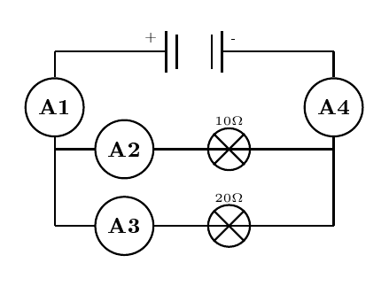
Circuit with two cells, two different bulbs and ammeters A1 to A4
A learner claims all four ammeters read the same because the bulbs are in the same circuit. Which statement identifies the error and gives the correct pairing? (1)
a. $A_{1}$ and $A_{4}$ have the same reading; $A_{2}$ and $A_{3}$ have different readings.
b. $A_{1}$, $A_{2}$, $A_{3}$ and $A_{4}$ all have the same reading.
c. $A_{1}$ and $A_{2}$ have the same reading; $A_{3}$ and $A_{4}$ have the same reading.
d. $A_{2}$ and $A_{3}$ have the same reading; $A_{1}$ and $A_{4}$ have different readings.

Question 17 1 mark
Study the following circuit diagram. A 12 V battery B1 is in series with two lamps L1 and L2 of different resistance. Voltmeter $V_{1}$ is across L1, voltmeter $V_{2}$ is across L2, and voltmeter $V_{3}$ is across both lamps together.
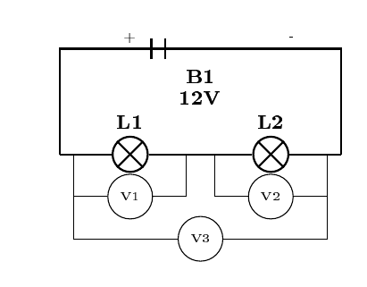
Circuit with battery B1, lamps L1 L2 and voltmeters V1 V2 V3
A learner claims $V_{1}$ must equal $V_{2}$ because the same current flows, and that their sum will then exceed $V_{3}$. How do the readings of $V_{1}$ and $V_{2}$ compare with $V_{3}$? Which statement corrects the error? (1)
a. The reading of $V_{1}$ equals the reading of $V_{2}$, and each equals the reading of $V_{3}$, because the current is the same.
b. The sum of the readings of $V_{1}$ and $V_{2}$ equals the reading of $V_{3}$, even though $V_{1}$ and $V_{2}$ differ.
c. The sum of the readings of $V_{1}$ and $V_{2}$ is less than the reading of $V_{3}$, because the wires use some voltage.
d. The sum of the readings of $V_{1}$, $V_{2}$ and $V_{3}$ equals the battery voltage.

Question 18 1 mark
Study the following diagram. A 12 V battery is connected to a $9 Ω$ resistor and a $6 Ω$ resistor in parallel.
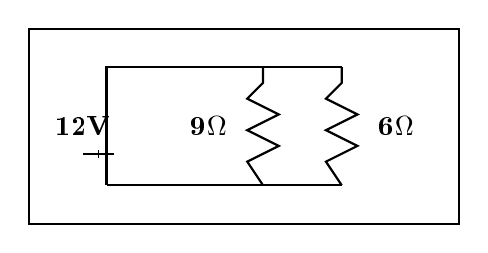
12V battery with 9 ohm and 6 ohm resistors in parallel
A learner claims half the total current flows through the $9 Ω$ resistor because current always splits equally, and that the larger resistor takes the larger share. What proportion of the total current flows through the $9 Ω$ resistor, correcting the error? (1)
a. $\frac{3}{5}$
b. $\frac{1}{2}$
c. $\frac{2}{5}$
d. $\frac{2}{3}$

Question 19 1 mark
The series circuit below has a battery of two $1.5 \text{V}$ cells, two bulbs and an ammeter. Jabu looks at the circuit and says: if a third bulb is added in series, the battery voltage will rise to push current through the extra bulb.
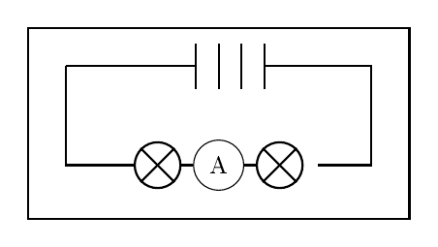
Series circuit with two cells, two bulbs and ammeter
Which statement correctly corrects Jabus error about the battery? (1)
a. The battery stays at $3.0 \text{V}$; the extra bulb only makes each bulb share less voltage.
b. The battery rises to $4.5 \text{V}$ to keep each bulb as bright as before.
c. The battery falls to $1.5 \text{V}$ because the voltage is shared between more bulbs.
d. The battery falls to zero because the bulbs use up all the voltage.

Question 20 1 mark
The picture shows illegal electricity connections at a substation in a residential area. A resident says these connections are harmless because they give free electricity without affecting anyone else.
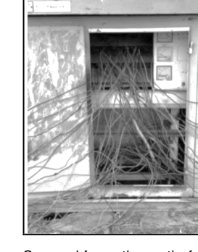
Illegal electricity connections at a substation
Which statement correctly corrects the residents error about this kind of connection? (1)
a. They are safe because the wires hang outside the houses.
b. They overload cables, which overheat and can cause power failures, fires and electrocution in the community.
c. They help to reduce load shedding because they bypass the meter.
d. They affect only the person who connected, not the neighbours.

Question 21 1 mark
A learner rewires the plug shown below and connects the brown wire to the earth pin, saying the live wire is a safety wire that only carries current during a fault, just like the earth wire. Which correction of the error about the live wire is correct? (1)
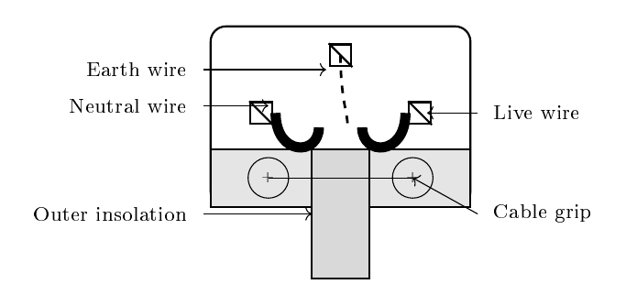
Three-pin plug wiring diagram
a. The live wire supplies current at mains voltage from the outlet to the appliance.
b. The live wire returns current from the appliance back to the outlet.
c. The live wire is a safety path that only carries fault current to earth.
d. The live wire blocks positive and negative current as electrons are pushed around.

Question 22 1 mark
Lerato claims South Africas main electricity source is solar power because the country receives a lot of sunshine. Which statement corrects her error? (1)
a. Solar power is the main source because sunshine directly creates the national grid.
b. Nuclear power is the main source because Koeberg alone powers the country.
c. Most electricity still comes from coal-fired stations built near coal mines, not from solar.
d. Hydropower from rivers is the main source because water is abundant.

Question 23 1 mark
About $5\%$ of South Africas electricity comes from the Koeberg nuclear power station, which uses uranium as fuel. A learner says the station burns uranium in air like coal to boil water.
Which statement correctly corrects the learners error about when heat is produced? (1)
a. Heat is produced when uranium is burned in oxygen like coal to heat water.
b. Heat is produced when heavy uranium nuclei split during nuclear fission, heating the water.
c. Heat is produced when light hydrogen atoms fuse together inside the reactor.
d. Heat is produced when the control rods burn up to keep the water hot.

Question 24 1 mark
A windy coastal town wants new electricity with the least harm to the environment. Sipho recommends biomass as the most sustainable choice because new plants can always be replanted. Which correction of Siphos error is correct? (1)
a. Biomass still produces smoke and needs much land and water, so wind renewable and emission-free during generation has less impact for this windy town.
b. Biomass has no impact because replanted trees absorb everything back.
c. Nuclear has least impact because a station with no smoke has no waste.
d. Solar creates radioactive waste during generation, so biomass is cleaner.

Question 25 1 mark
The pie chart shows how electricity was used in a household in one month. The total consumption for the month was 360 kWh.
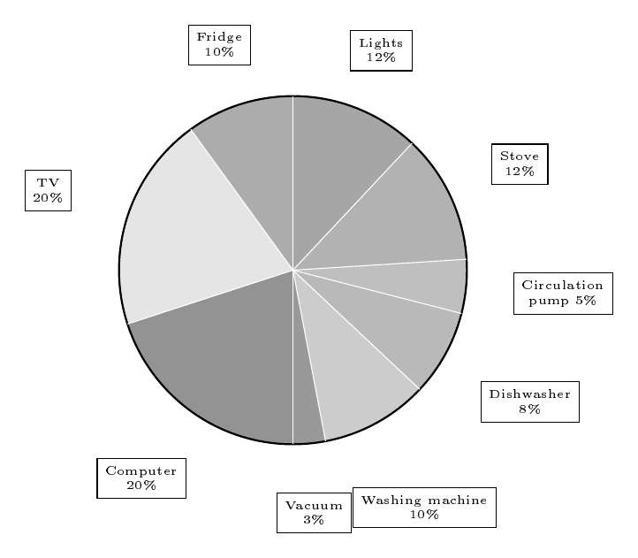
Pie chart of household electricity use
Lerato says the TV used 20 kWh because the chart shows 20%. This confuses the percentage with the energy. What is the correct energy used by the TV? (1)
a. 20 kWh
b. 18 kWh
c. 72 kWh
d. 180 kWh

Question 26 1 mark
Neo writes that kWh means kilowatts per hour. Which option corrects her error and gives what kWh really stands for? (1)
a. kilowatts per hour
b. kilowatt hour
c. kilowatt
d. kilojoule per hour

Question 27 1 mark
A class discusses how the solar panels that heat water with sunlight make electricity. Jabu says sunlight knocks protons out of the silicon in the cells to make the current.
Which statement corrects Jabu’s error about protons and describes what really happens when photons hit the solar cells? (1)
a. Protons are knocked loose and flow as current.
b. Photons are released by the cells.
c. Electrons are knocked loose, forming an electric current.
d. Heat alone boils water to drive a generator in the panel.

Question 28 1 mark
A kettle rated at 2000 W is used for 15 minutes. The municipal tariff is R2,50 per kWh.
Pieter multiplies 2000 0,25 to get 500 kWh and a cost of R1 250, forgetting to convert watts to kilowatts. What is the correct cost after fixing his conversion error? (1)
a. R1 250,00
b. R500,00
c. R12,50
d. R1,25

Question 29 1 mark
A prefect claims standby uses no power and cheap incandescent bulbs save energy. Which is the most effective and sustainable way of reducing household energy use, correcting that idea? (1)
a. Leave the TV and computer on standby overnight so they stay ready.
b. Use incandescent bulbs because they are cheaper to buy.
c. Boil a full kettle each time for one cup to save time.
d. Fit LED lamps and switch appliances fully off instead of standby.

Question 30 1 mark
Lena claims a solar geyser stores the Sun so it always gives equally hot water, even without sunshine. Which is the most correct statement about solar geysers, correcting her error? (1)
a. It gives equally hot water day and night regardless of sunshine.
b. Its panels contain dangerous pollutants that heat the water.
c. It can never get water as hot as an electrical geyser.
d. The availability of hot water depends on sunshine and weather.

Question 31 1 mark
A learner claims: Magnesium is found in the liquid outer core, which is part of the lithosphere. Which statement identifies the error and gives the correct position? (1)
a. The error is the layer and the grouping: magnesium is abundant in the mantle and crust that make up the lithosphere, not in the outer core, and the liquid outer core is not part of the lithosphere
b. There is no error: the liquid outer core is part of the lithosphere and holds most of the magnesium
c. The error is the state: magnesium is in the solid inner core of the lithosphere, not in the liquid outer core
d. The error is the process: magnesium in the outer core turns into iron under pressure, so the outer core is correctly called iron-nickel

Question 32 1 mark
The diagram shows how the four spheres of the Earth interact during a volcanic eruption in the centre. Arrows link LITHO, HYDRO, ATMO and BIO.
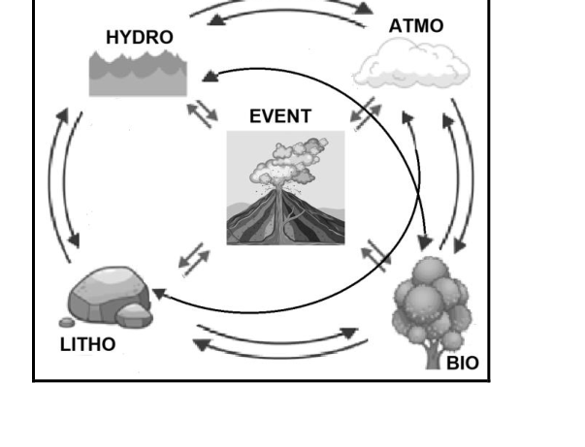
Interactions amongst spheres of the Earth with volcanic eruption
A learner describes the diagram as: The atmosphere erupts hot lava that melts lithosphere ice, and the floodwater drowns the hydrosphere forests. Which sequence corrects the sphere errors and best represents the interaction? (1)
a. Lithosphere releases lava and ash Atmosphere carries ash and gases Hydrosphere glacier melts and rivers flood Biosphere streamside forest and communities are damaged
b. Atmosphere erupts hot lava Lithosphere ice melts Hydrosphere forests drown Biosphere clouds form
c. Hydrosphere erupts lava Atmosphere melts Lithosphere floods Biosphere rains
d. Biosphere erupts ash Hydrosphere carries lava Atmosphere floods Lithosphere trees die

Question 33 1 mark
A revision card says: The lithosphere is the sphere containing all liquid and gaseous water plus the air around Earth. Which statement identifies the error and correctly defines the lithosphere? (1)
a. There is no error: the lithosphere does contain all water and air around Earth
b. The error confuses hydrosphere and atmosphere with lithosphere: the lithosphere is the rigid rocky outer layer of crust plus uppermost mantle, not water or air
c. The error is omitting life: the lithosphere contains only living things including micro-organisms
d. The error is omitting gas: the lithosphere contains all solid, liquid and gaseous water of the planet

Question 34 1 mark
A learner writes for rusting iron: $2Fe+3O→Fe_{2}O_{3}$ and claims it is balanced because 2 irons and 3 oxygens match. Which statement identifies the conceptual error and gives the correct equation? (1)
a. There is no conceptual error: $2Fe+3O→Fe_{2}O_{3}$ is correct because atom counts match
b. The error is using atomic $O$ and a false balance: oxygen occurs as $O_{2}$, so the balanced equation is $4Fe+3O_{2}→2Fe_{2}O_{3}$
c. The error is the product: the correct balanced equation is $Fe_{2}+3O_{2}→2FeO_{2}$
d. The error is the coefficients: the correct balanced equation is $4Fe+2O→2Fe_{2}O$

Question 35 1 mark
A learner claims: Plutonic (intrusive) rocks form when lava erupts, cools quickly on the surface and traps gas bubbles to make large crystals. Which statement pinpoints the error and correctly describes plutonic formation? (1)
a. There is no error: plutonic rocks do form from lava cooling quickly on the surface with trapped gas bubbles
b. The error confuses intrusive with extrusive: plutonic rocks form when magma cools and crystallises slowly deep in the crust, giving coarse crystals; fast surface cooling with bubbles is volcanic
c. The error is the location: plutonic rocks result from magma reaching the surface either as lava or fragmental volcanic pieces
d. The error is the texture: plutonic rocks result from gas expansion or bubbles which occur during volcanic eruptions

Question 36 1 mark
A learner lists the four most abundant elements in Earth9s crust as silicon, aluminium, iron and copper, arguing valuable metals must be most common. Which change corrects the error in the list? (1)
a. There is no error: copper is among the four most abundant crustal elements
b. Replace copper with oxygen, giving oxygen, silicon, aluminium and iron
c. Replace aluminium with copper, giving oxygen, silicon, copper and iron
d. Replace oxygen with carbon, giving carbon, silicon, aluminium and iron

Question 37 1 mark
The diagram shows the rock cycle. Magma, igneous rock, sediment, sedimentary rock and metamorphic rock are linked by arrows for melting, weathering and erosion, and heat and pressure, plus three numbered arrows 1, 2 and 3.
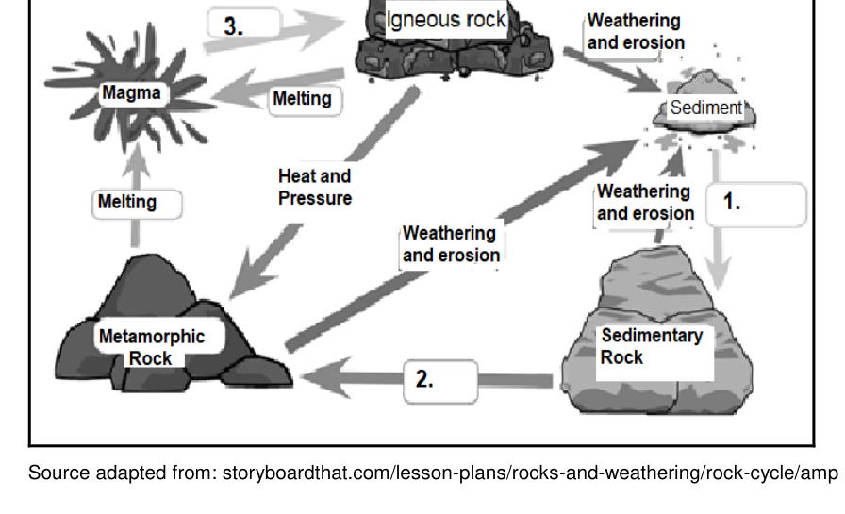
Different stages of the rock cycle
A learner labels the diagram: 1 is melting of sediment, 2 is weathering and erosion of sedimentary rock, and 3 is heat and pressure forming igneous rock. Which option identifies the learner’s mistake and gives the correct processes for 1, 2 and 3? (1)
a. The mistake is mixing up destructive and forming processes; 1 is compaction and cementation, 2 is heat and pressure, 3 is cooling and crystallisation
b. Only 1 is wrong; 1 is heat and pressure, 2 is weathering and erosion, 3 is heat and pressure
c. Only 3 is wrong; 1 is compaction and cementation, 2 is melting, 3 is heat and pressure
d. There is no mistake; 1 is melting, 2 is weathering and erosion, and 3 is heat and pressure in that order

Question 38 1 mark
The atmosphere of the Earth is the layer of gases held by Earth’s gravity around the planet. The main gases are nitrogen, oxygen, argon and carbon dioxide, present in very different proportions.
A learner copies a chart as: oxygen 78%, nitrogen 21%, carbon dioxide 0.93% and argon 0.04%. Which option spots the learner’s error and gives the correct combination? (1)
a. Nitrogen 78%, Oxygen 21%, Argon 0.93%, Carbon Dioxide 0.04%
b. Oxygen 78%, Nitrogen 21%, Carbon Dioxide 0.93%, Argon 0.04%
c. Nitrogen 0.04%, Oxygen 21%, Argon 78%, Carbon Dioxide 0.93%
d. Carbon Dioxide 78%, Oxygen 21%, Argon 0.93%, Nitrogen 0.04%

Question 39 1 mark
Moving upward from the troposphere to the thermosphere, a learner claims air gets denser because the thermosphere is hotter and heat adds more particles. Which statement corrects this error? (1)
a. Density decreases as altitude increases, as air higher up has fewer molecules per cubic metre
b. Density increases as altitude increases, because the hotter thermosphere packs in more molecules
c. Density stays the same from troposphere to thermosphere, because gravity holds the same amount of air at all heights
d. Density decreases as altitude decreases, because lower layers are thinned by the cold air above

Question 40 1 mark
A learner’s revision card reads: the troposphere is the middle layer about 50 km up where ozone absorbs heat. Which option corrects both errors in this card? (1)
a. The troposphere is the lowest layer, about 12 km up, where clouds and weather occur
b. The troposphere is the second layer, about 50 km up, where meteors burn up
c. The troposphere is the third layer, about 85 km up, where satellites orbit
d. The troposphere is the fourth and thickest layer, about 350 km up, where temperature rises sharply

Question 41 1 mark
A learner points to the row: 20 km, to 30 , contains the ozone layer, and says this is the mesosphere. Which row correctly gives the mesosphere and shows the learner confused it with the stratosphere? (1)
a. Upper limit about 85 km, to , meteors burn up here
b. Upper limit about 15 km, 15 to , weather and Earth’s surface
c. Upper limit about 50 km, to 0 , ozone layer absorbs ultraviolet
d. Upper limit about 600 km, 500 to 1500 , satellites orbit here

Question 42 2 marks
(a) A class places one thermometer in a sealed transparent plastic bag in sunlight and one outside the bag. Both readings climb, but the bagged one reads higher. A learner says the bagged reading is faulty and says nothing about the atmosphere. Which statement corrects the learner and explains the greenhouse analogy? (1)
a. The bag traps outgoing heat like greenhouse gases do, so the higher reading models how extra greenhouse gases raise Earth’s temperature
b. The bag blocks sunlight, so the higher reading shows greenhouse gases cool Earth by trapping cold air
c. The bag has no effect and both thermometers should read the same, so any difference is experimental error
d. The bag makes the thermometer faulty, so the outside readings alone prove warming has no effect

(b) Using the corrected bag model, the teacher asks what will happen if greenhouse-gas concentration keeps rising while sunlight input stays the same. Which prediction correctly applies the model? (1)
a. Mean Earth temperature will keep rising because less escaping heat gets out, like adding a thicker cover
b. Mean Earth temperature will fall because thicker gases block more incoming sunlight from reaching the surface
c. Mean Earth temperature will stay the same because temperature depends only on the Sun, as the bag experiment shows
d. Outside-bag readings will rise but inside-bag readings will fall, proving plastic has the opposite effect in the real atmosphere

Question 43 6 marks
(a) A learner writes the smelting of haematite as $Fe_{2}O_{3}+C→2Fe+CO_{2}$ and claims it is balanced because the iron atoms are equal on both sides. Which option identifies the error in counting atoms and gives the correct balanced equation for reduction of iron(III) oxide by carbon? (1)
a. $Fe_{2}O_{3}+C→2Fe+CO_{2}$ because the iron atoms are already equal
b. $2Fe_{2}O_{3}+3C→4Fe+3CO_{2}$ because all Fe, C and O atoms balance
c. $2Fe_{2}O_{3}+3C→4Fe+6CO$ because carbon forms monoxide in a furnace
d. $Fe_{2}O_{3}+3C→2Fe+3CO_{2}$ because only carbon and oxygen need coefficients

(b) The same learner then writes the reduction by carbon monoxide as $Fe_{2}O_{3}+CO→Fe+CO_{2}$ and says only the iron needs a coefficient. Which option points out that carbon and oxygen must also balance and gives the correct equation? (1)
a. $Fe_{2}O_{3}+3CO→2Fe+3CO_{2}$ with Fe, C and O all balanced
b. $Fe_{2}O_{3}+CO→2Fe+CO_{2}$ with only iron balanced
c. $2Fe_{2}O_{3}+3CO→4Fe+3CO_{2}$ with extra $Fe_{2}O_{3}$ added
d. $Fe_{2}O_{3}+3CO→Fe+3CO_{2}$ with carbon monoxide left unbalanced for iron

(c) Crushed nickel ore is stirred with water and oil, air is blown through, and the mineral-rich froth is skimmed off. A learner calls this distillation because a separation occurs. Which option corrects the error and names the method? (1)
a. Froth flotation — the error is calling it distillation, as there is no boiling and condensing, but air bubbles carry mineral particles in froth
b. Distillation — the error is doubting the learner, as any separation by density is distillation
c. Electrolysis — the error is using oil instead of acid, as the separation needs an electric current
d. Chromatography — the error is using water, as the separation needs ink moving on paper

(d) A community discovers a copper deposit. An adviser tells them to send the blasted rock straight to the smelter, skipping crushing and concentration to save time. Which advice corrects this error about getting value from the discovery? (1)
a. Send the blasted rock straight to the smelter to save the cost of crushing
b. Crush and mill the rock, then concentrate by flotation to raise the metal content before smelting
c. Sink all the mined rock in water and smelt only the rocks that float
d. Spread the uncrushed rock on the ground and pick out shiny pieces by hand only

(e) A representative tells the Xolobeni community that benefits from titanium mining mean only the closest households gain, with no need to repair the land. Which statement corrects this exclusive view of mining benefits? (1)
a. Only households nearest the pit should get jobs and royalties, and the pit can be left open afterwards
b. All profits should go to a foreign company, and employment alone is enough benefit for the community
c. Benefits should be shared through jobs, infrastructure and rehabilitation planned with government and the community for long-term development
d. Mining should benefit everyone living anywhere in Africa regardless of damage to local land and water

(f) A learner describes magnetic separation as stirring powdered ore with water in a pan and fishing out minerals with a hand magnet. Which option identifies the mistake in scaling up this description and correctly explains magnetic separation in an iron-ore plant? (1)
a. Powdered ore is ground until it is flour-fine, and fineness alone separates the iron
b. Crushed ore falls over rotating magnetic rollers that pull magnetic iron minerals away from non-magnetic waste
c. Ore is mixed with water in a pan and a hand magnet fishes minerals from the mud, which is the full plant method
d. Large electromagnets melt the iron out of the rock by heating the whole mixture

Question 44 2 marks
(a) A learner claims the main sequence stage is when clouds of dust and gas first collapse under gravity to form a protostar. Which option identifies the error and correctly describes what happens during the main sequence stage? (1)
a. It is when dust and gas first collapse under gravity to form a protostar, so fusion has not started
b. It is the long stable period when hydrogen fuses to helium, releasing energy that balances gravitational collapse
c. It is when the star swells and cools to become a red giant after fuel runs out
d. It is when the star explodes as a supernova and leaves a neutron star or black hole

(b) In a life-cycle diagram for a Sun-like star, A follows the main sequence, B follows the planetary nebula and C is the final cold stage. A learner labels them A neutron star, B white dwarf and C protostar. Which option corrects the error? (1)
a. A red giant, B white dwarf and C black dwarf
b. A neutron star, B white dwarf and C protostar
c. A black hole, B supernova and C red supergiant
d. A black dwarf, B red giant and C white dwarf in that order

SECTION B
Answer all questions to the best of your ability.

Question 45 1 mark
Figure A shows the magnetic field around Earth and Figure B shows the field around a bar magnet.
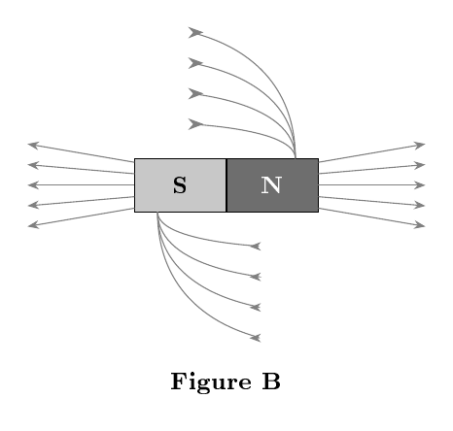
Figure B bar magnet field
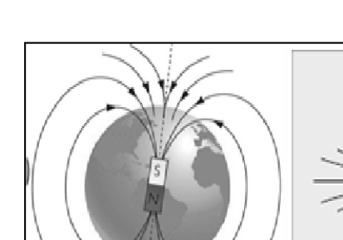
Figure A Earth magnetic field
A learner says the field in Figure A cannot be compared to Figure B because Earth has no bar magnet inside and has only one magnetic pole. Point out the error and briefly compare the two fields. (1)

Question 46 2 marks
A teacher holds a flat sheet of paper in one hand and a stone in the other at the same height above the classroom floor and releases them at the same time to show the effect of air on falling objects.
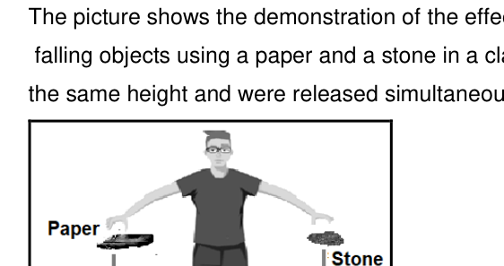
Person dropping paper and stone
A learner predicts both will land together because gravity is the same on both. State which object hits the ground first, identify the error in the prediction and give the correct reason. (2)

Question 47 1 mark
The effect of the thickness of a wire on its resistance was investigated using a battery pack, an ammeter, a voltmeter and four nichrome wires of the same length but different diameters, connected one at a time in the same circuit.
A learner says the independent variable is the ammeter reading because it changes during the test. Identify the error and state the independent variable. (1)

Question 48 2 marks
The reading of ammeter $A_{1}$ is 2.4 A and the potential difference across the battery is 6 V. The potential difference across $R_{1}$ is 1.4 V and across $R_{3}$ is 2.1 V.
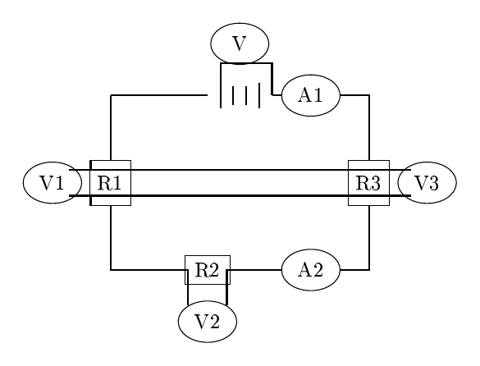
Series circuit with R1 R2 R3
A learner adds the two known voltages to the battery voltage to get the voltage across $R_{2}$. Correct the method and calculate the potential difference across $R_{2}$ in V. (2)
Answer: ________________

Question 49 1 mark
A learner writes: Koeberg is the best power station because nuclear fuel never runs out and it leaves no dangerous waste, so South Africa should use only nuclear power. Identify the error in this statement and state one real advantage of using nuclear power such as Koeberg. (1)

Question 50 1 mark
Lerato claims that rain and snow form in the stratosphere inside the ozone layer because all weather clouds are found there. Correct her error by naming the atmospheric layer in which precipitation actually takes place. (1)

Question 51 1 mark
A revision card states: Sedimentary rocks form when magma cools and then is changed by intense heat and pressure. Point out the wrong process in this description and correctly describe how sedimentary rocks are formed. (1)

Question 52 1 mark
The stratosphere contains the ozone layer, which protects living things by absorbing most of the Suns harmful ultraviolet radiation before it reaches Earths surface.
Thabo suggests that using more aerosol sprays containing CFCs and releasing more smoke will help thicken the ozone layer. Explain the error in his idea and suggest one action that would actually avoid depletion of the ozone layer. (1)

Question 53 1 mark
Open-cast mining near towns in Gauteng and Mpumalanga creates dust, blasting vibrations and polluted runoff that reach nearby homes, schools and water supplies.
A mine manager claims that living next to the mine is harmless because dust, noise and blasting have no effect on people or houses. Identify the error in this claim and name one real negative impact of mining operations close to residential areas. (1)

Question 54 1 mark
Astronomers use a stars colour to estimate its surface temperature and stage of life.
Colour | Blue-white | Yellow-white | Red |
Temp in Kelvin | above 10 000 K | about 5 500 K | below 3 500 K |
A learner predicts that a red star is the youngest because red means hotter and newer, followed by yellow-white and then blue-white as oldest. Correct this error by arranging a red, a yellow-white and a blue-white star in order from youngest to oldest. (1)

Answer key
Question 1
a
Question 2
a
Question 3
a
Question 4
a
Question 5
a
Question 6
a
Question 7
b
Question 8
(a) a
(b) c
Question 9
(a) a
(b) c
Question 10
d
Question 11
(a) b
(b) b
Question 12
(a) a
(b) d
Question 13
(a) a
(b) b
Question 14
(a) a
(b) c
Question 15
(a) d
(b) b
Question 16
a
Question 17
b
Question 18
c
Question 19
a
Question 20
b
Question 21
a
Question 22
c
Question 23
b
Question 24
a
Question 25
c
Question 26
b
Question 27
c
Question 28
d
Question 29
d
Question 30
d
Question 31
a
Question 32
a
Question 33
b
Question 34
b
Question 35
b
Question 36
b
Question 37
a
Question 38
a
Question 39
a
Question 40
a
Question 41
a
Question 42
(a) a
(b) a
Question 43
(a) b
(b) a
(c) a
(d) b
(e) c
(f) b
Question 44
(a) b
(b) a
Question 45
Error is Earth acts as a dipole with north and south magnetic poles like a bar magnet, field lines form similar closed loops leaving one pole and entering the other (1)
Question 46
Stone hits the ground first (1)
Error is ignoring air resistance: gravity is similar but large surface area to mass of flat paper gives much larger upward air resistance slowing the paper (1)
Question 47
Error is ammeter reading is the dependent variable measured to calculate resistance, independent variable is thickness / diameter of the wire (1)
Question 48
2.5
Question 49
error is that uranium is finite and nuclear power produces dangerous high-level radioactive waste needing safe storage; real advantage is reliable large-scale electricity with very low carbon dioxide / greenhouse-gas emissions during generation (1)
Question 50
error is that weather clouds are not in the stratosphere/ozone layer; precipitation takes place in the troposphere (1)
Question 51
error is confusing sedimentary formation with igneous cooling and metamorphic heat/pressure; sedimentary rocks form by weathering, erosion, deposition, compaction and cementation of sediments in layers (1)
Question 52
error is that CFCs / chlorinated chemicals destroy ozone rather than build it; avoid depletion by banning/reducing CFCs and using ozone-friendly alternatives / enforcing Montreal Protocol controls (1)
Question 53
error is that dust/blasting do harm health, buildings and environment; one real impact e.g. respiratory illness from dust / cracked houses from blasting vibrations / noise pollution / contamination of drinking water / loss of land for housing (1)
Question 54
error is that red is coolest/oldest not hottest/youngest; correct youngest to oldest order is blue-white, then yellow-white, then red (1)

